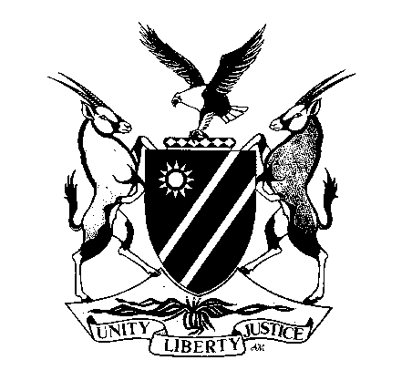
REPUBLIC OF NAMIBIA
MINISTRY OF MINES AND ENERGY

APPLICATION FOR PERMIT TO PURCHASE, SELL, DEAL IN, RECEIVE OR DISPOSE OF, OR BE IN POSSESSION OF, HIGH VALUE MINERALS
(required in terms of Section 105 of the Minerals (Prospecting and Mining) Act, 33 of 1992)

1) Full Name of Applicant: . . . . . . . . . . . . . . . . . . . . . . . . . . . . . . . . . . . . . . . . . . . . . . . . . . . . . . . . . . . . . . . . . . . . .
In the case of a Person;
Namibian Identity Document No.: . . . . . . . . . . . . . . . . . . . . . . . . . . . . . . . . . . . . . . . . . . . . . . . . . . . . . . . . . .
or Permanent Residence No.: . . . . . . . . . . . . . . . . . . . . . . . . . . . . . . . . . . . . . . . . . . . . . . . . . . . . . . . . . . . . . .

In the case of a Company;
Certificate of Incorporation No.: . . . . . . . . . . . . . . . . . . . . . . . . . . . . . . . . . . . . . . . . . . . . . . . . . . . . . . . . . . .
Certificate of Registration to Commence Business No.: . . . . . . . . . . . . . . . . . . . . . . . . . . . . . . . . . . . . . . . . . .
Trading Licence No.: . . . . . . . . . . . . . . . . . . . . . . . . . . . . . . . . . . . . . . . . . . . . . . . . . . . . . . . . . . . . . . . . . . . .

Physical Address: . . . . . . . . . . . . . . . . . . . . . . . . . . . . . . . . . . . . . . . . . . . . . . . . . . . . . . . . . . . . . . . . . . . . . . . . . . .
Registered Postal Address: . . . . . . . . . . . . . . . . . . . . . . . . . . . . . . . . . . . . . . . . . . . . . . . . . . . . . . . . . . . . . . . . . . .
Telephone No.: . . . . . . . . . . . . . . . . . . . . . . . . . . . . . . . . . . Fax No.: . . . . . . . . . . . . . . . . . . . . . . . . . . . . . . . ….
E-Mail: ………………………………………………………………………………………………………………

2) High Value Minerals permit required for (tick relevant block):
Jewellery Manufacturing
Mineral Dealer
Dental Laboratory
Other (please specify) |  | . . . . . . . . . . . . . . . . . . . . . . . . . . . . . . . . . . . . . . . . . .

3) Permit required for the year: . . . . . . . . . . . . . . . . . . .

4) In the case of a person who has been convicted, in the ten years period preceding the date of this application, of an offence by a court of law in respect of which the person was sentenced to imprisonment, whether suspended or not, without the option of a fine, indicate -

Date of Conviction: . . . . . . . . . . . . . . . . . . . . . . . . .. Place of Conviction: . . . . . . . . . . . . . . . . . . . . . . . .
Nature of Offence: . . . . . . . . . . . . . . . . . . . . . . . . . . Sentence: . . . . . . . . . . . . . . . . . . . . . . . . . . . . . . . .
(Append separate sheet if necessary)

5) The original Certificate of Conduct (CoC) issued by the Namibian Police must be attached. *
In the case of a company, a Certificate of Conduct (CoC) of each director must be attached. *
The prescribed application fee of N$1 000-00 must be attached to this application.
* The CoC must not be older than three months on the date of application.

__________________________________ ______________ ______________________
NAME IN FULL (Block Letters) SIGNATURE DATE
Please attach certified copies of (tick relevant blocks):

Namibian Identity Document
Permanent Residence Permit
Certificate of Incorporation
Certificate of Registration to Commence Business
Trading Licence
Certificate of relevant qualification(s) |  | Please specify: . . . . . . . . . . . . . . . . . . . . . . . . . . . . . . .

Please note that in terms section 104 of the Minerals (Prospecting and Mining) Act, 1992 any person who is not the holder of a mining claim or a mineral licence in respect of high value minerals is required, in terms of section 105 of the Act, to apply to the Commissioner for a permit to purchase, sell, deal in, receive or dispose of, or to be in possession of such minerals. By definition, high value minerals are unwrought precious metals (gold, silver, and platinum group elements, not exceeding 10 gram in mass) and any rough, uncut tourmaline, garnet, emerald, ruby or sapphire.

